FINAL PROJECT REPORT

ON

“BLOOD BANK MANAGEMENT SYSTEM”

Submitted in partial fulfillment of the requirements for the award of degree of

BACHELOR OF ENGINEERING IN

COMPUTER SCIENCE & ENGINEERING

Submitted to: Er JYOTI ARORA

Submitted By:

DIBYAJYOTI DEV RAY (20BCS2860)

RITIK CHAUHAN (20BCS2849)

DEPARTMENT OF COMPUTER SCIENCE & ENGINEERING

Chandigarh University, Gharuan

Contents

Topic

Certificate

Students ’s Declaration

Acknowledgement

CLASS A (BRIEF INRO & REQUIREMENTS)

CLASS B (SCOPE OF THE PROJECT)

CLASS C (RESULTS)

CLASS D (FUTURE SCOPE)

CERTIFICATE

This is to certify that the work embodied in this Project Report entitled “BLOOD BANK MANAGEMENT SYSTEM”, being submitted by “20BCS2860, 20BCS2849”in their summer term for partial fulfillment of the requirement for the degree of “ Bachelor of Engineering in Computer Science & Engineering ”discipline in “Chandigarh University” during the academic session JAN-JUNE 2021 is a record of bona fide piece of work, carried out by student under my supervision and guidance in the “ Department of Computer Science & Engineering ”, Chandigarh University

DECLARATION

We, student of Bachelor of Engineering in Computer Science & Engineering, after our 1st year, session: JAN-JUNE 2021, Chandigarh University, hereby declare that the work presented in this Project Report entitled “BLOOD BANK MANAGEMENT SYSTEM” is the outcome of our own work, is bona fide and correct to the best of our knowledge and this work has been carried out taking care of Engineering Ethics. The work presented does not infringe any patent work and has not been submitted to any other university or anywhere else for the award of any degree or any professional diploma.

Students details and Signature

DIBYAJYOTI DEV RAY (20BCS2860)

RITIK CHAUHAN (20BCS2849)

APPROVED & GUIDED BY:

To our Project In charge “ER JYOTI ARORA”.

ACKNOWLEDGEMENT

We would like to express our deep and sincere gratitude to our Project In charge ER JYOTI ARORA for giving us the opportunity to do the project and providing valuable guidance throughout this research. Their dynamism, vision and exquisite efforts have deeply inspired us. They taught us the methodology to carry out the research and to present the research work as clearly as possible. It was a great privilege for us to study and work under their guidance.

CLASS A

BRIEF INTRODUCTION

BLOOD BANK MANAGEMENT SYSTEM is a ‘WEBSITE’ designed to maintain day to day transactions in a blood bank. This website helps to register all the donors, Blood collection details etc. Blood banks collect, store, and provide blood. Typically, these banks collect blood from voluntary blood donors. The banks then sort blood by type, check blood to make sure it is free of disease and then store it for future use. The main mission of a blood bank is to provide life-saving blood to hospitals and other health care facilities. Blood cannot be created by any means, it can only be collected from the Humans i.e., donors. A blood bank is a bank of blood or blood components, gathered as a result of blood donation, stored and preserved for later use in blood transfusion. To satisfy blood necessity, to buy, sale and stock.

What the purpose?

Online Blood Bank aims to serving for human welfare. We have all the information; you will need. It is very easy to use. It saves a lot of time. The portal acts as an office that is open 24/7

Many people are ready to help you, willing to donate blood for you anytime. Search the blood group you need. You can help us by registering on Online Blood Bank if you are willing to donate your blood when needed. As a proud member of Blood Bank and a responsible human being, you can help someone in need. So, donate blood in online.

Requirements

Software:

HTML

HTML stands for Hyper Text Markup Language. It is the standard markup language for creating Web pages. It describes the structure of a Web page. It consists of a series of elements. HTML elements tell the browser how to display the content.HTML elements label pieces of content such as “this is a heading”, “this is a paragraph”, “this is a link”, etc.

Hypertext Markup Language (HTML) is the standard markup language for documents designed to be displayed in a web browser. It can be assisted by technologies such as Cascading Style Sheets (CSS) and scripting languages such as JavaScript

CSS

CSS stands for Cascading Style Sheets. CSS describes how HTML elements are to be displayed on screen, paper, or in other media. CSS saves a lot of work. It can control the layout of multiple web pages all at once. External stylesheets are stored in CSS files

PHP

PHP is a general-purpose scripting language that is especially suited to web development. It was originally created by Danish-Canadian programmer Rasmus Lerdorf in 1994; the PHP reference implementation is now produced by The PHP Group. PHP originally stood for Personal Home Page,[7] but it now stands for the recursive initialism PHP: Hypertext Preprocessor.

MY SQL

SQL is a standard language for accessing and manipulating databases. SQL stands for Structured Query Language. SQL lets you access and manipulate databases. SQL became a standard of the American National Standards Institute (ANSI) in 1986, and of the International Organization for Standardization (ISO) in 1987

SQL can execute queries against a database, retrieve data, insert records in a database, update records, delete records, create new databases, create new tables in a database, create stored procedures in a database, create views in a database, set permissions on tables, procedures, and views

Class B

SCOPE OF THE PROJECT

In this project mainly 2 modules are there.

1. Admin

2. Donor

Definitions

Donor: The person who donate the blood

Admin: Person who ensures of keeping a website running efficiently and securely

Admin:

This module focuses on the admin only. Each member in a admin is asked make a user id and password, which identifies him uniquely. The member is given a login form. he enters the login details user id and password. The options given to the user are

•Maintain donor details

•Update donor details

•Maintain Visitors Experiences

•Logout/Login

Change Password

Whenever a user wants to change his / her password he can select the forgot password option. The system displays the form, which asks him for his old password and new password. The system then compares the old password with the existing password in the database

Donor:

Each member in a Donor is given a user id and password, which identifies him uniquely. The member is given a login form. he enters the login details user id and password. The options given to each member are Change password.

Class C

Results

Snapshots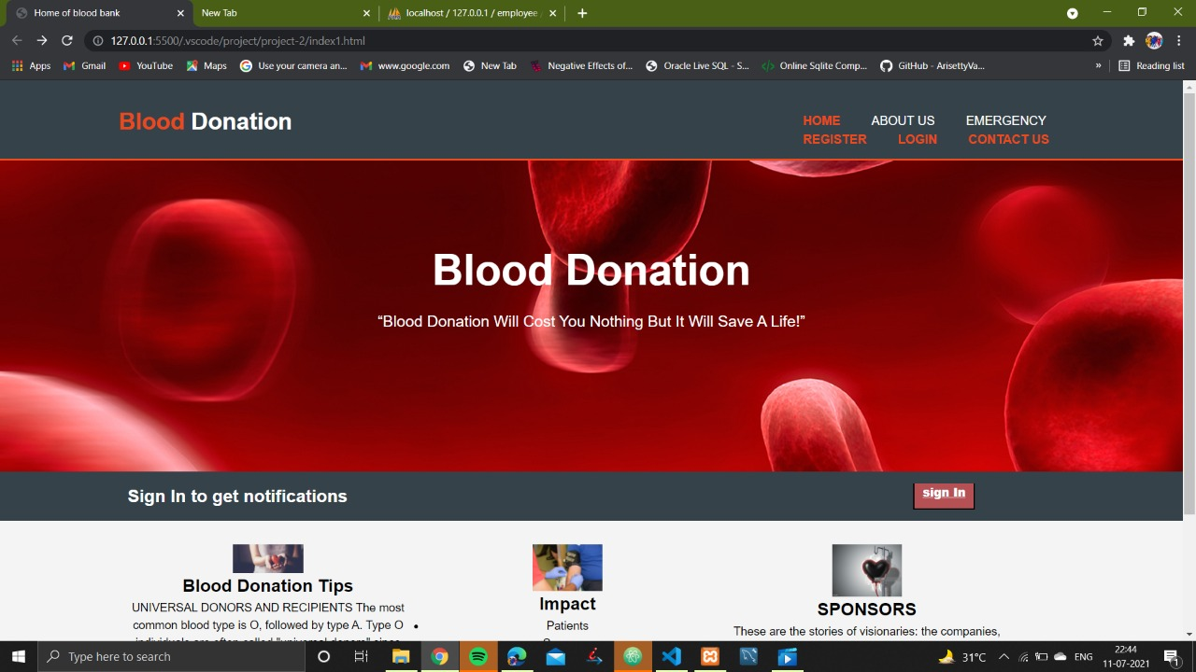:

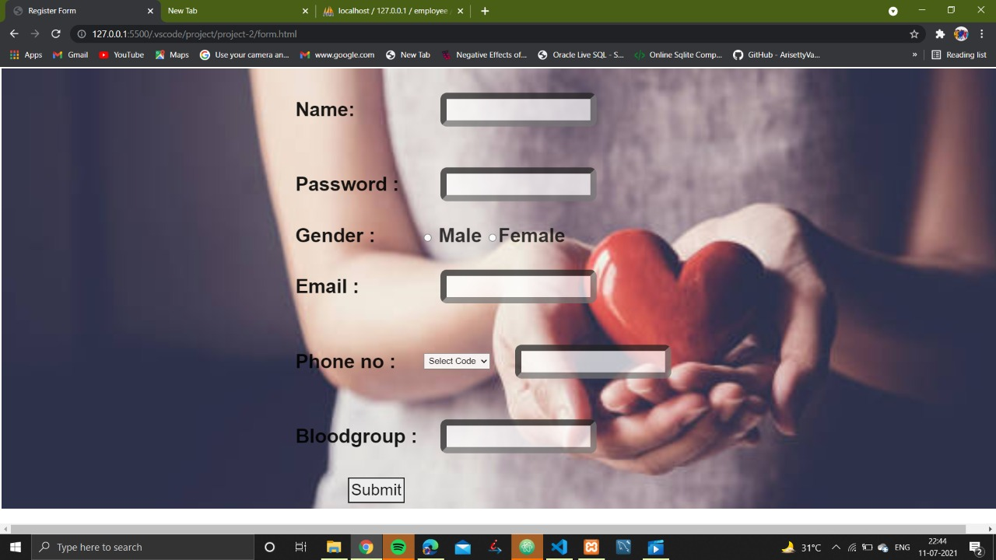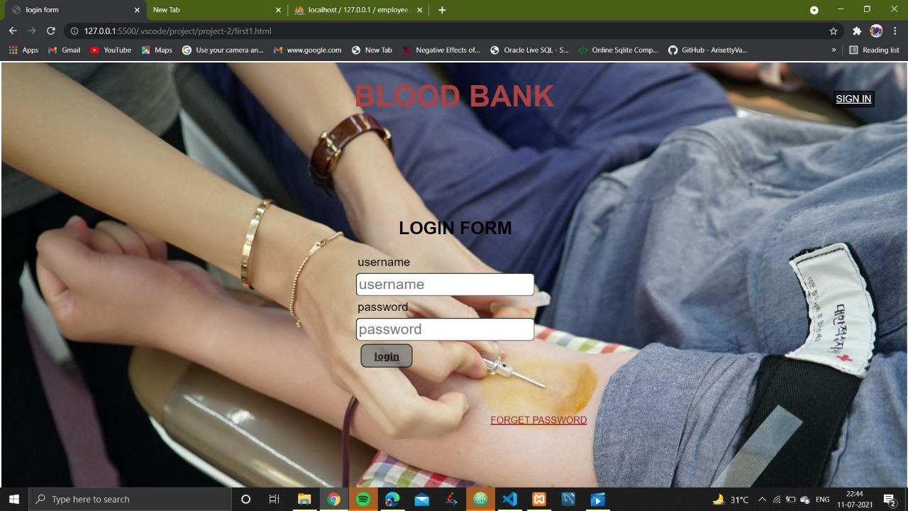

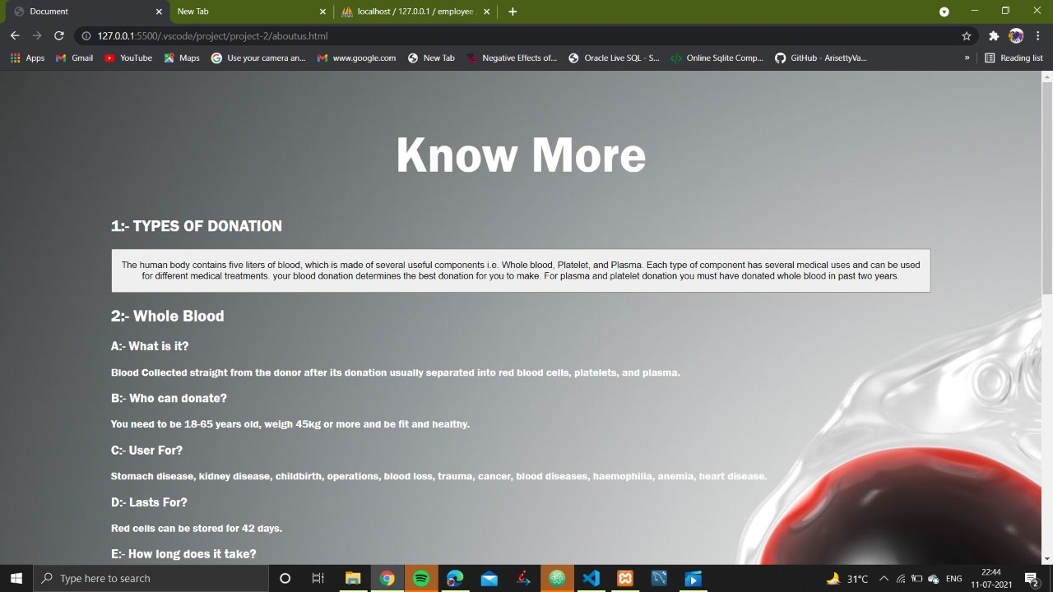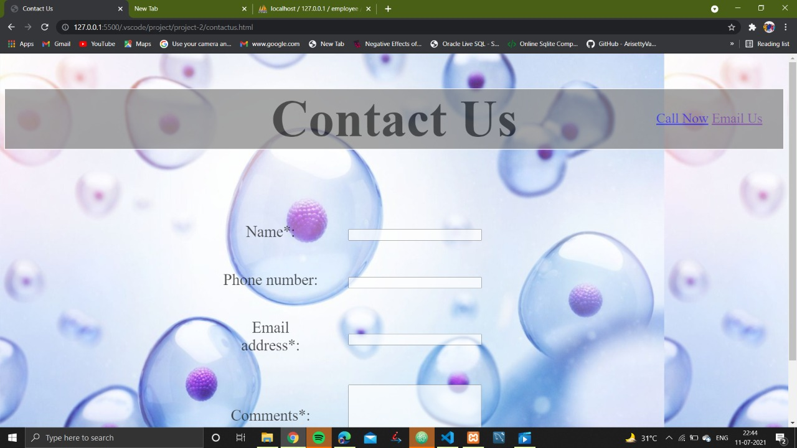

Code:

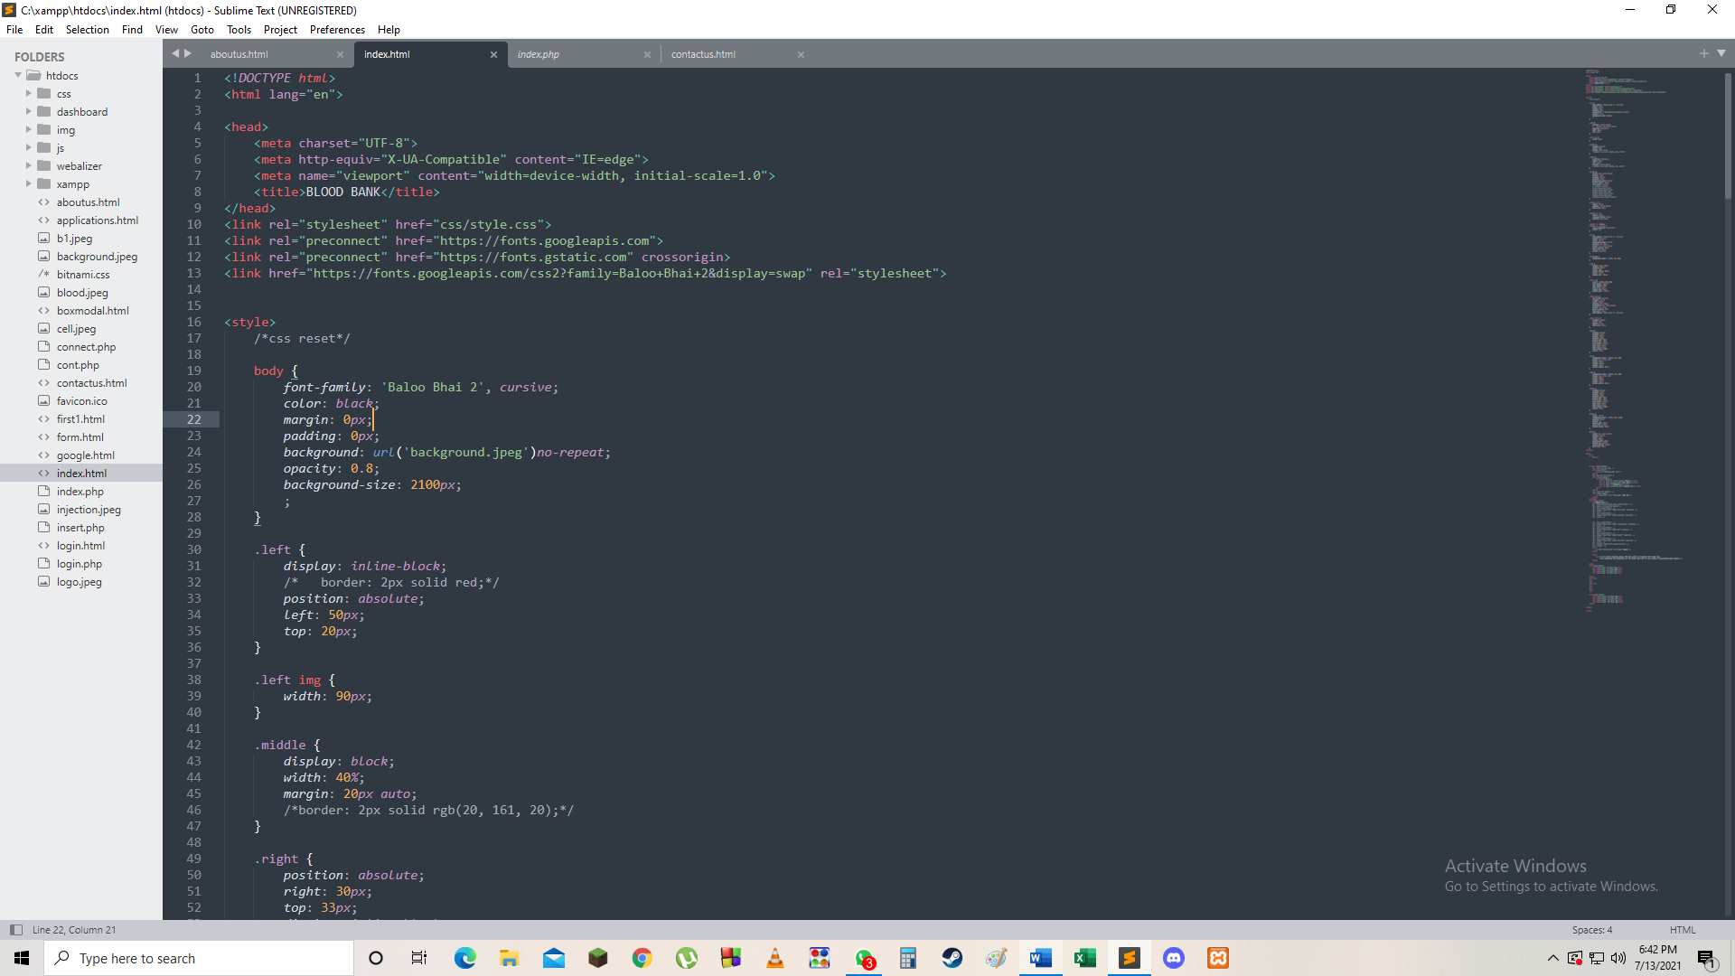

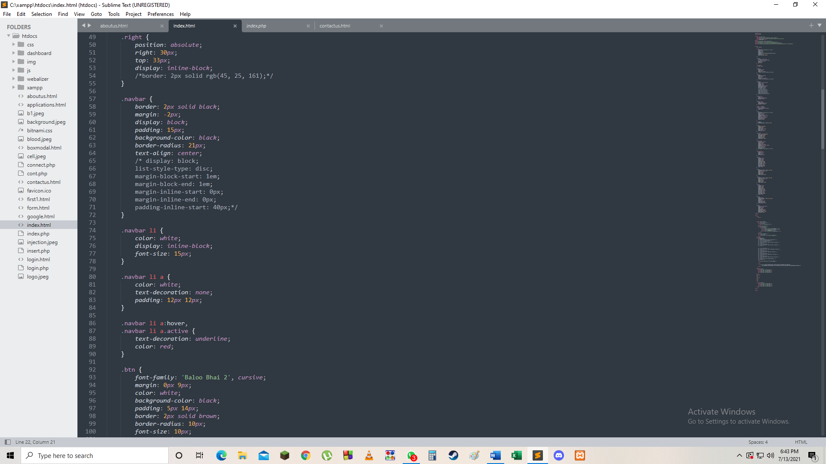

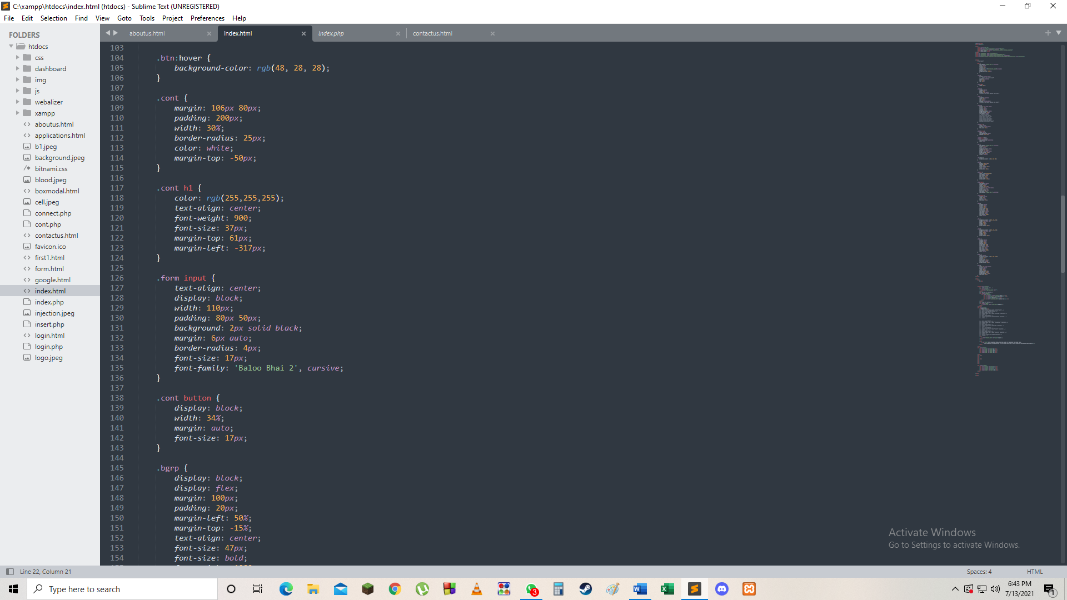

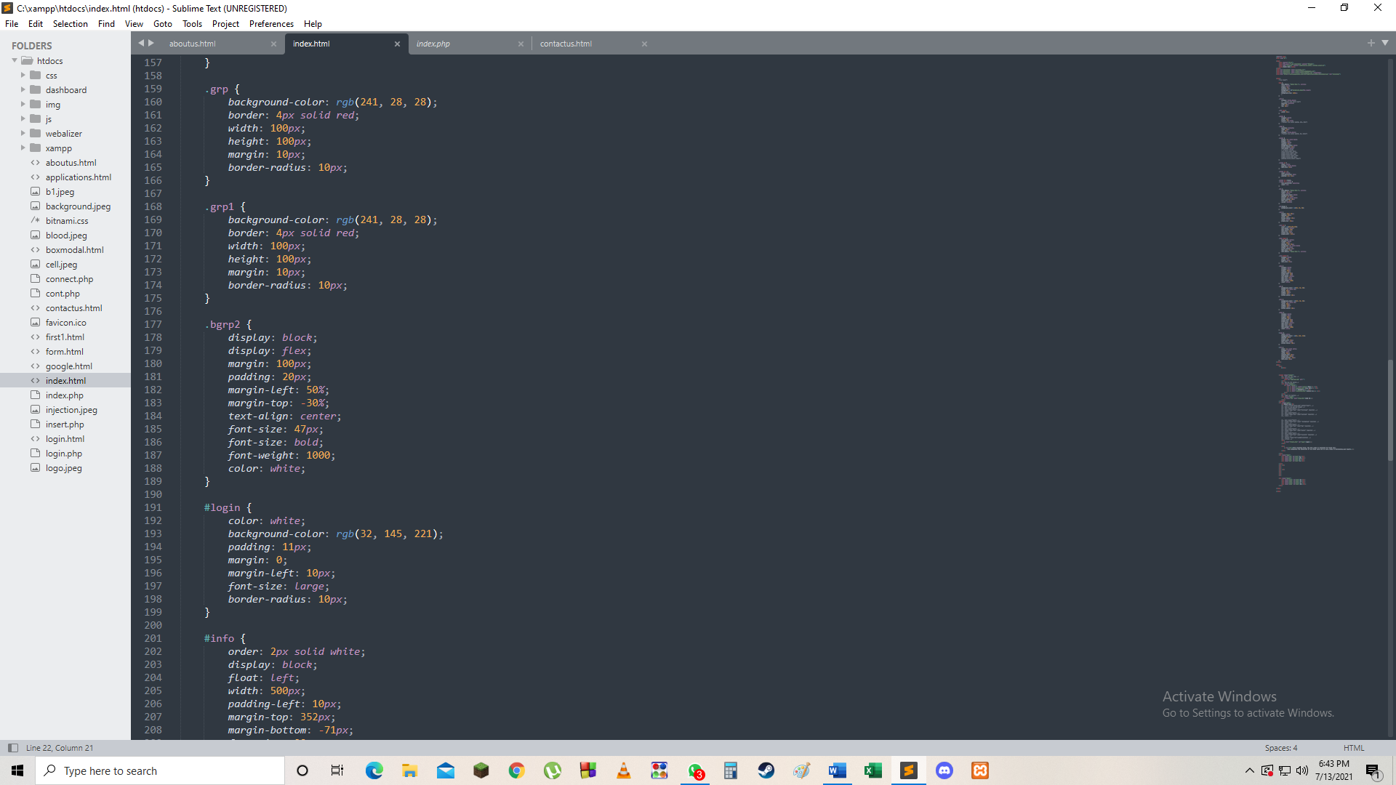

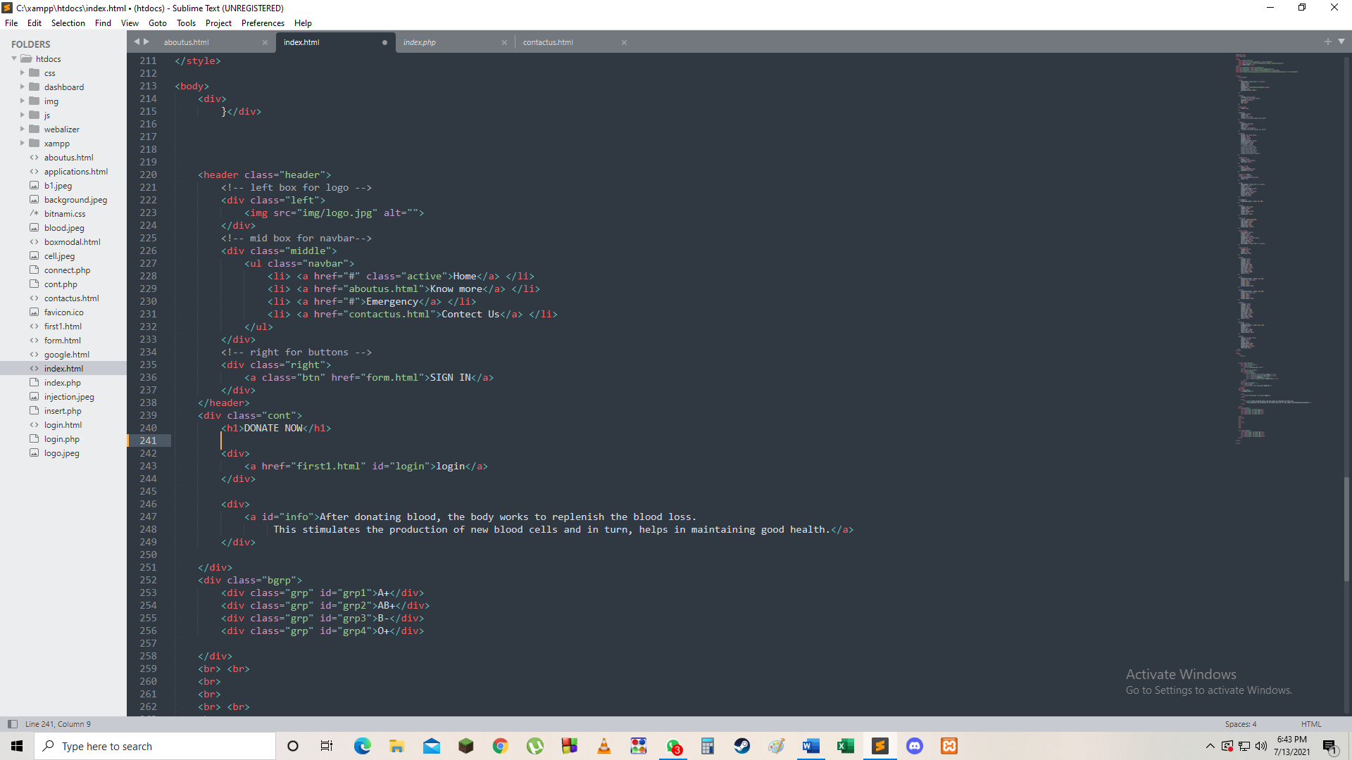

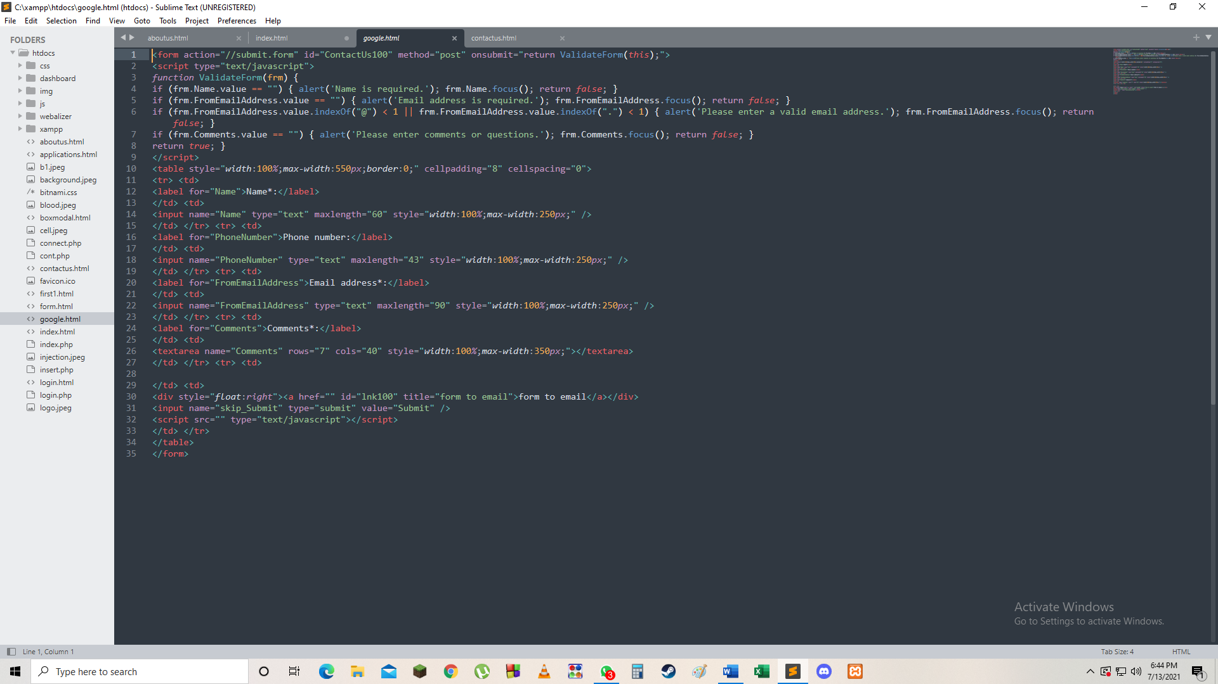

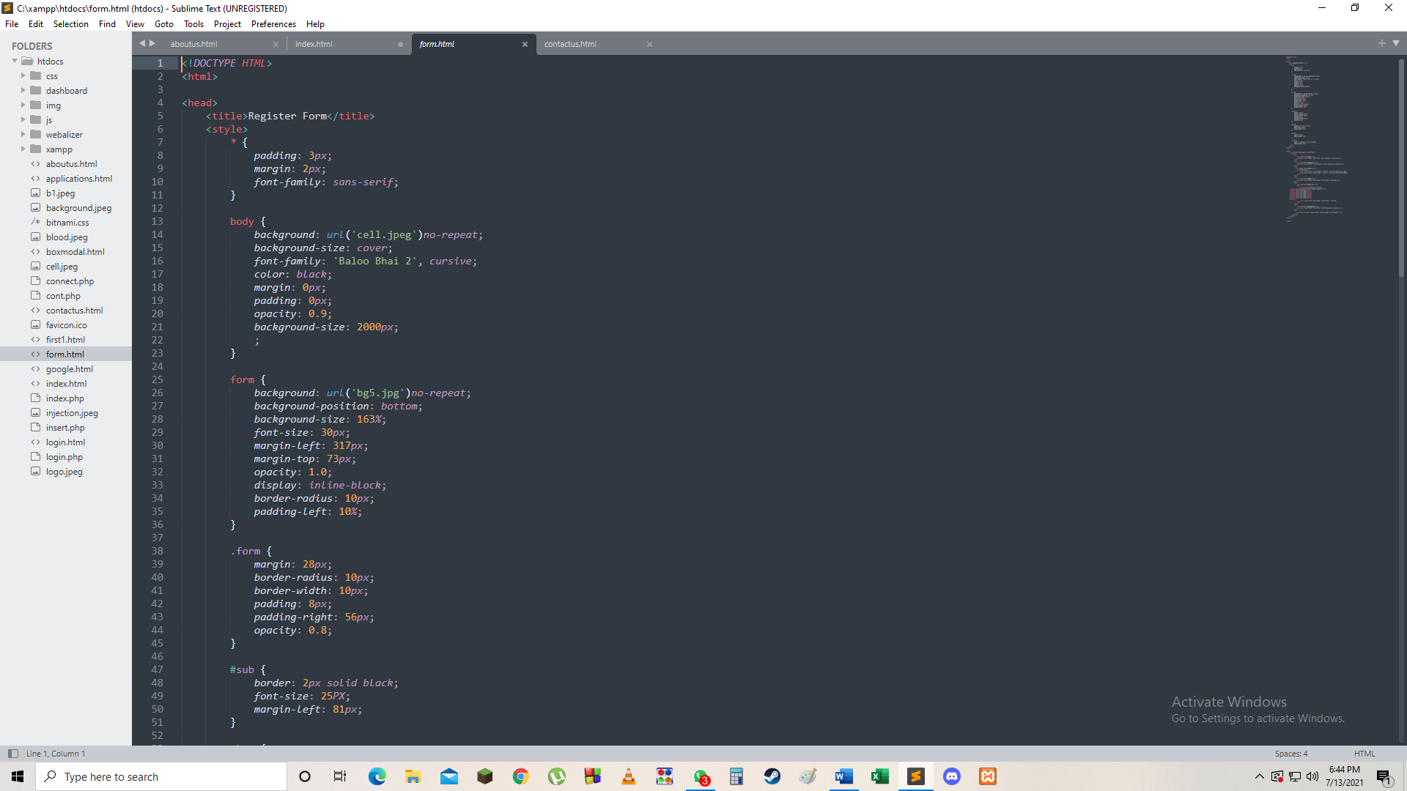

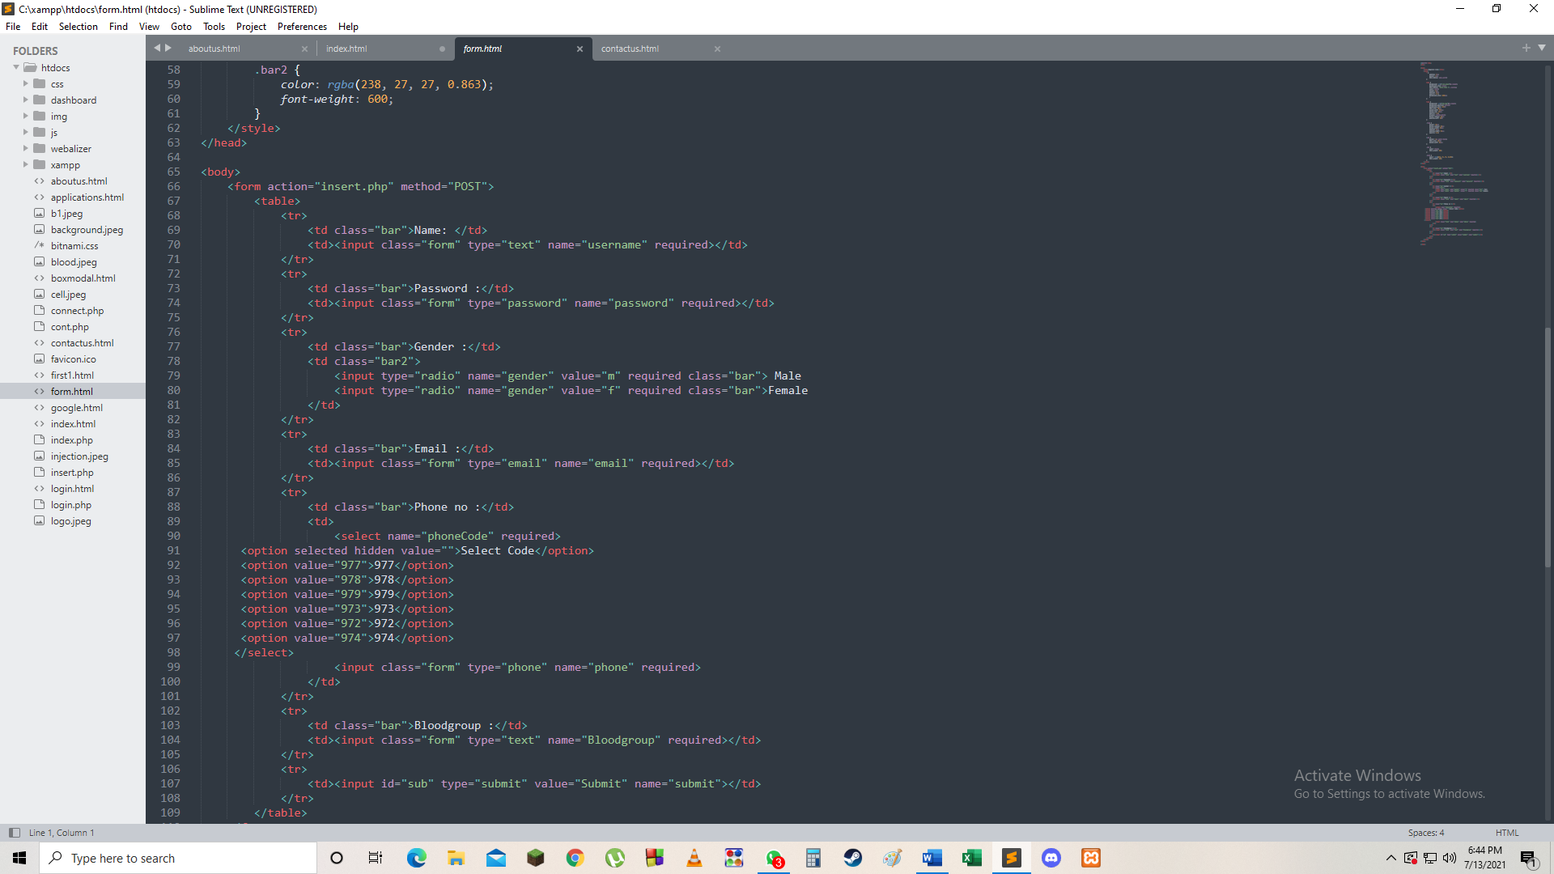

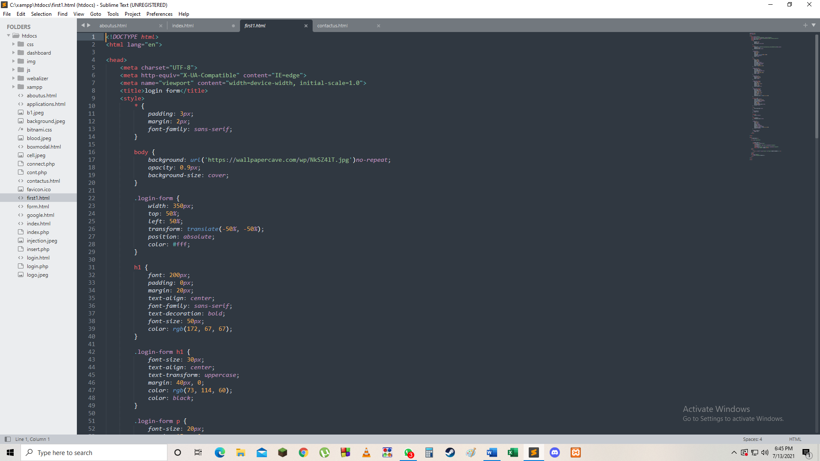

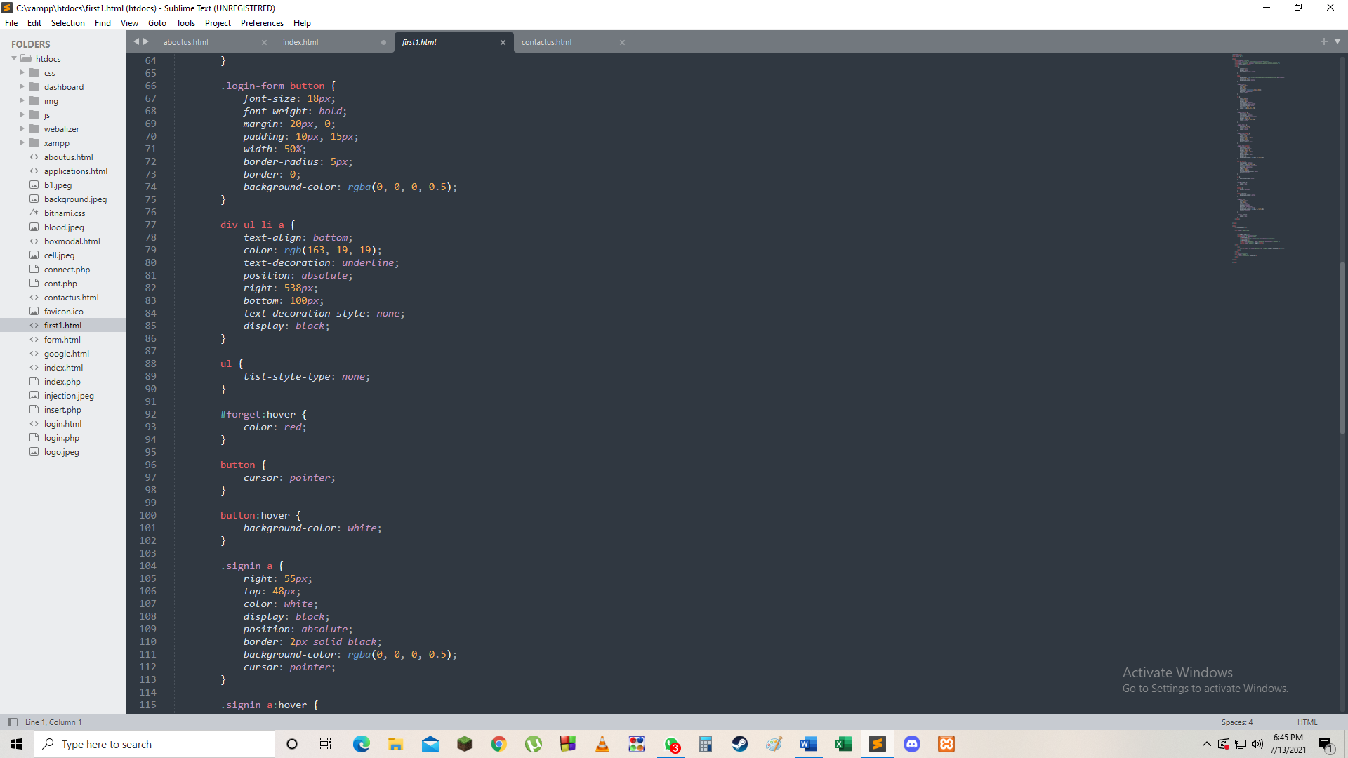

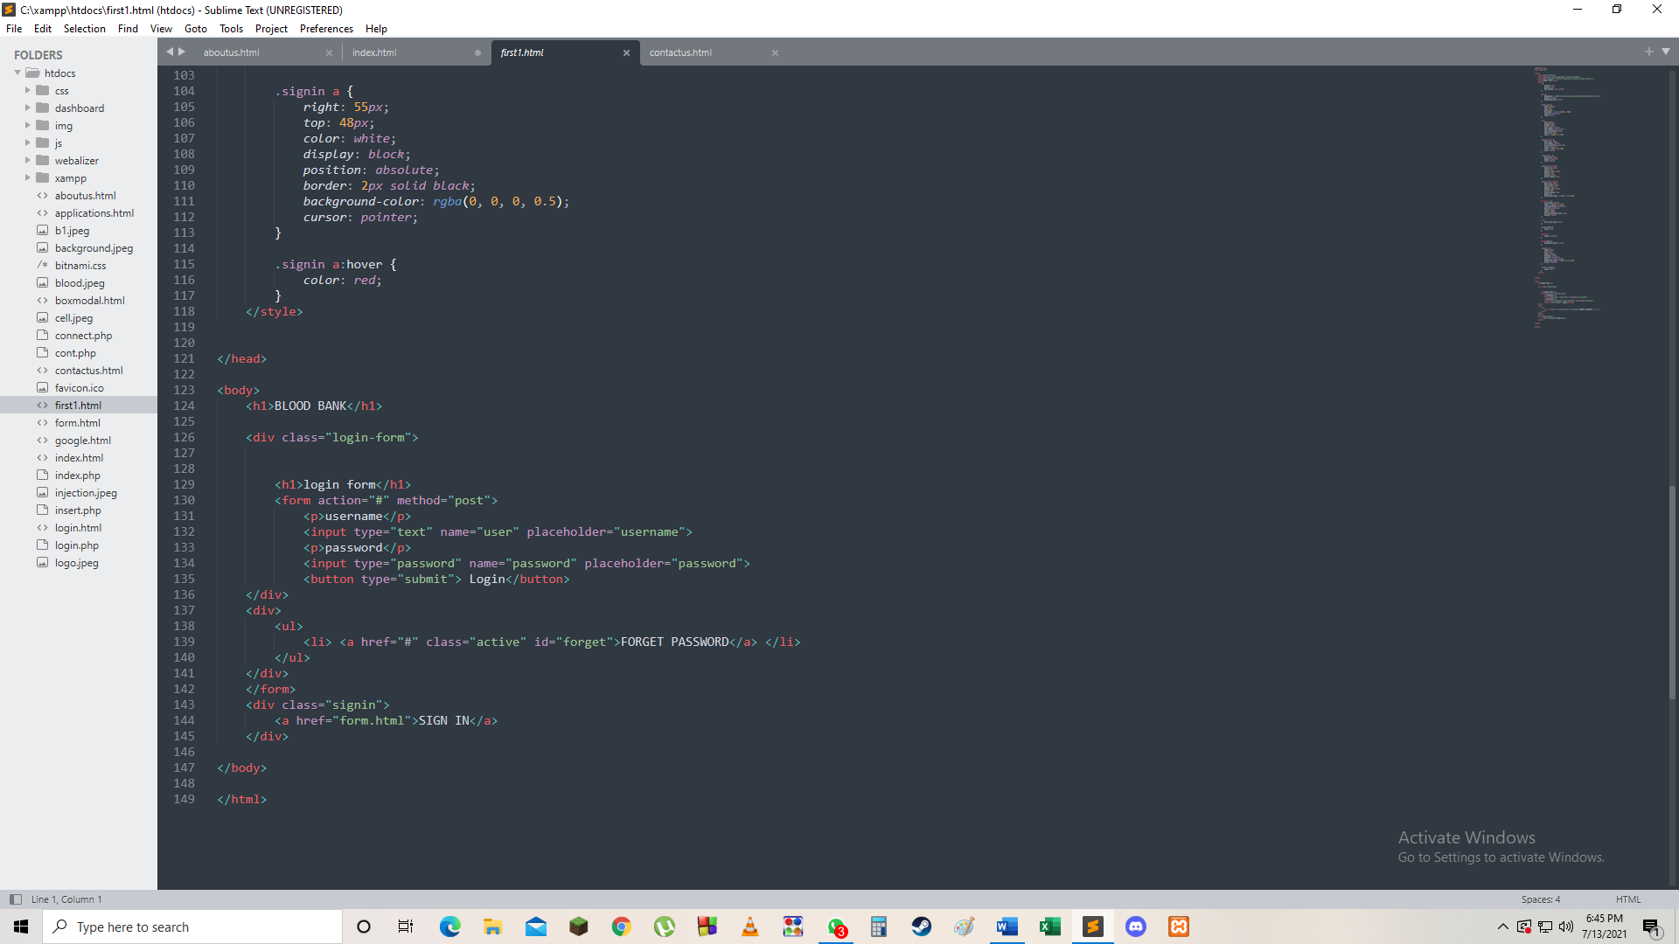

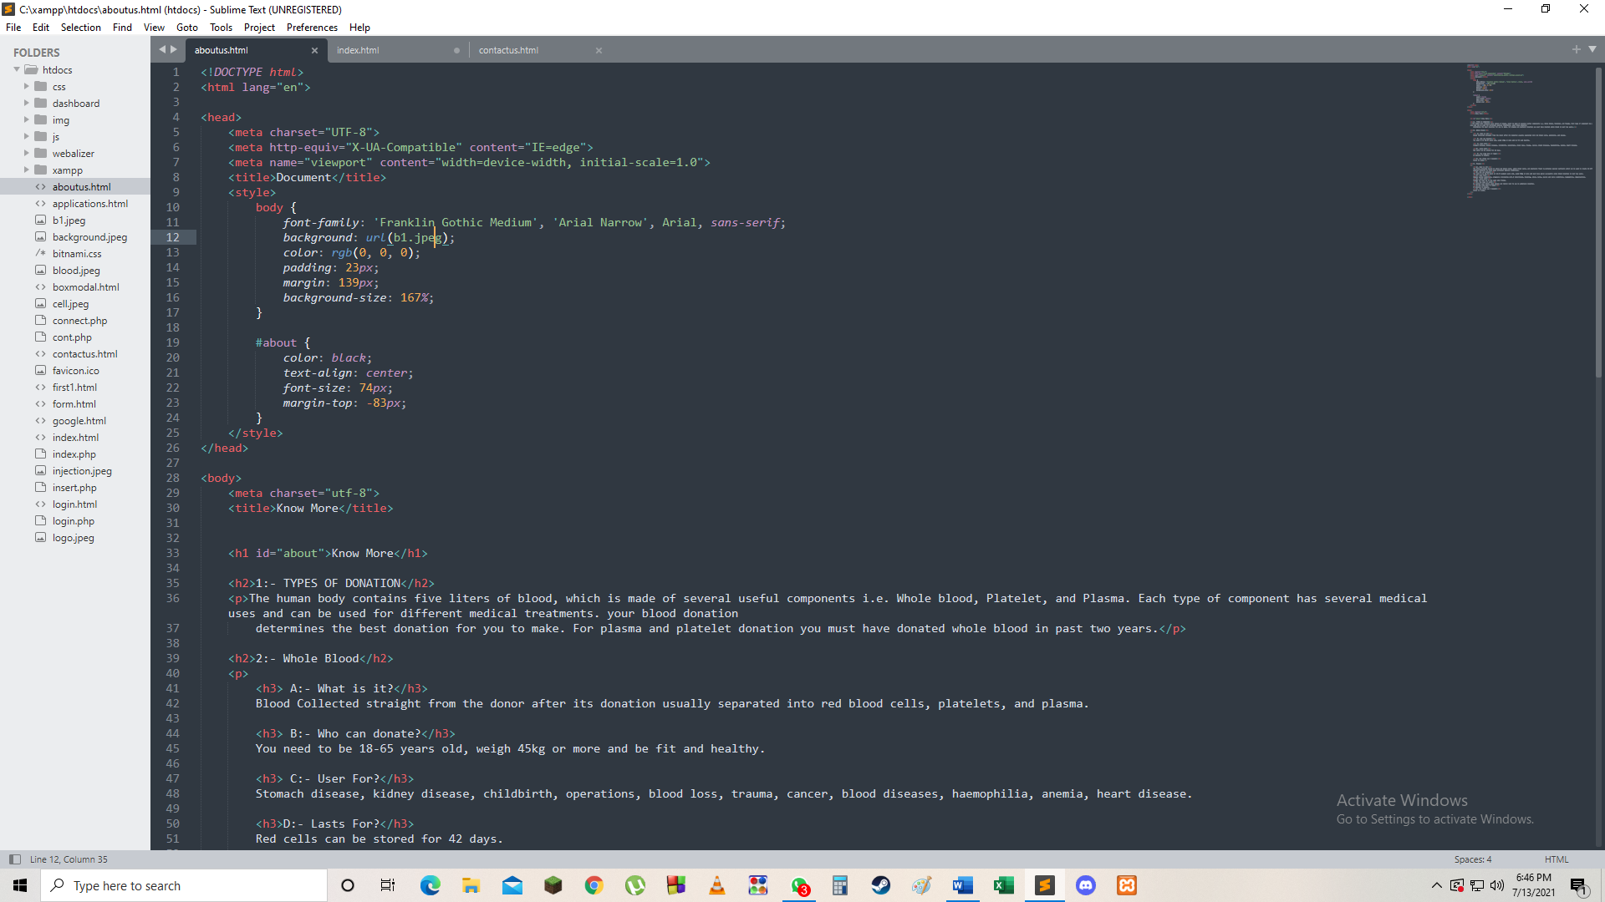

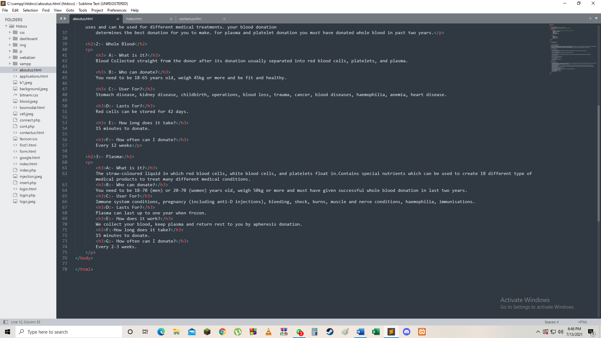

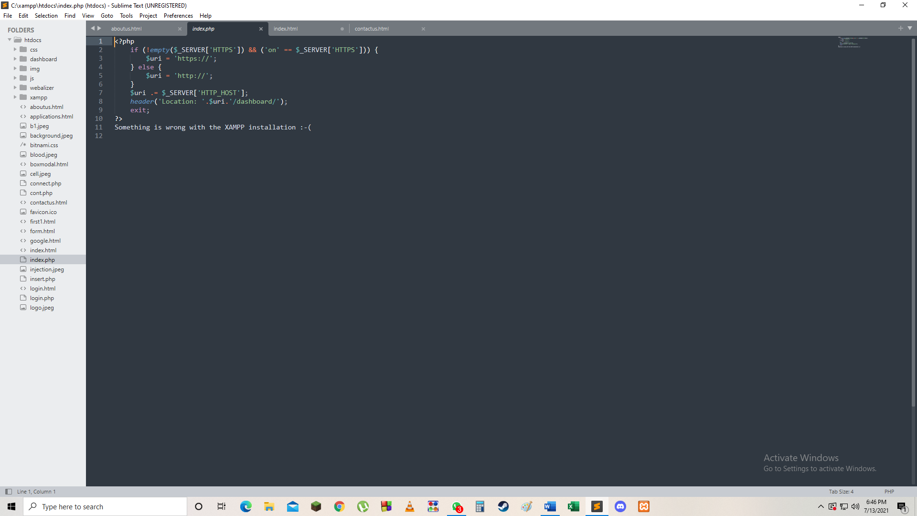

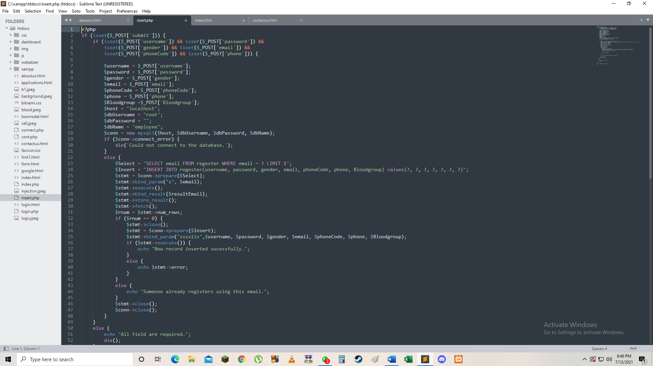

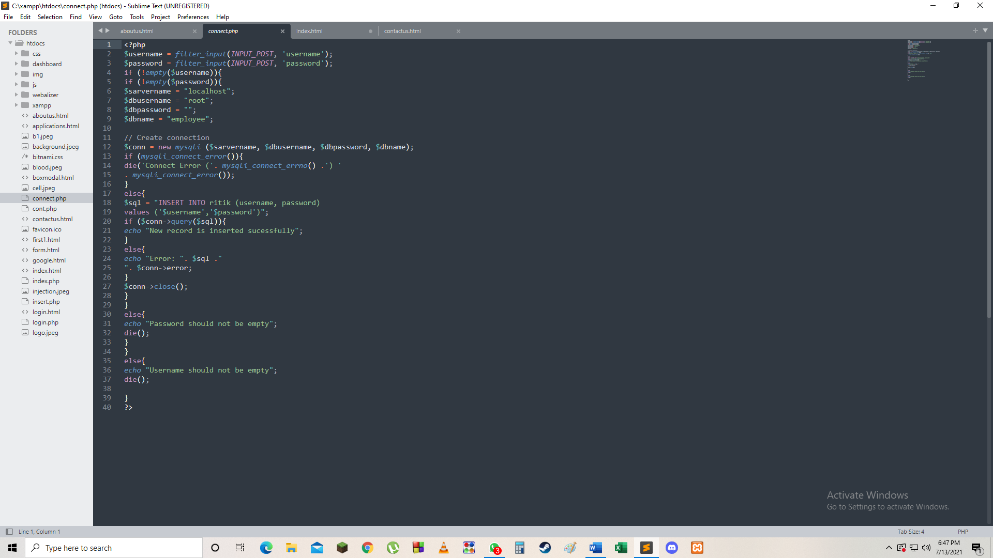

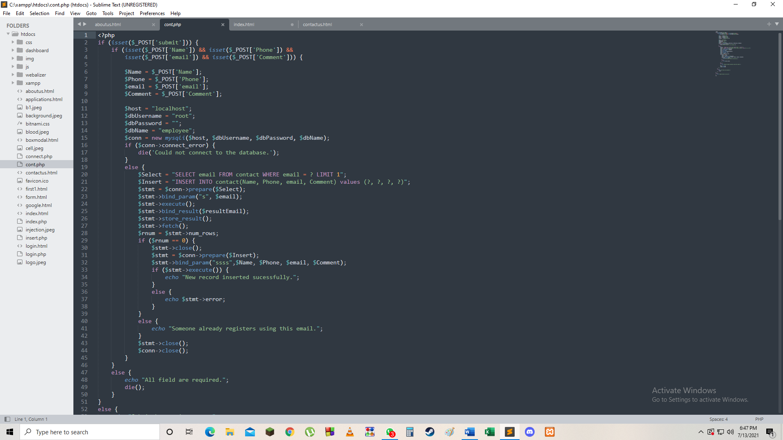

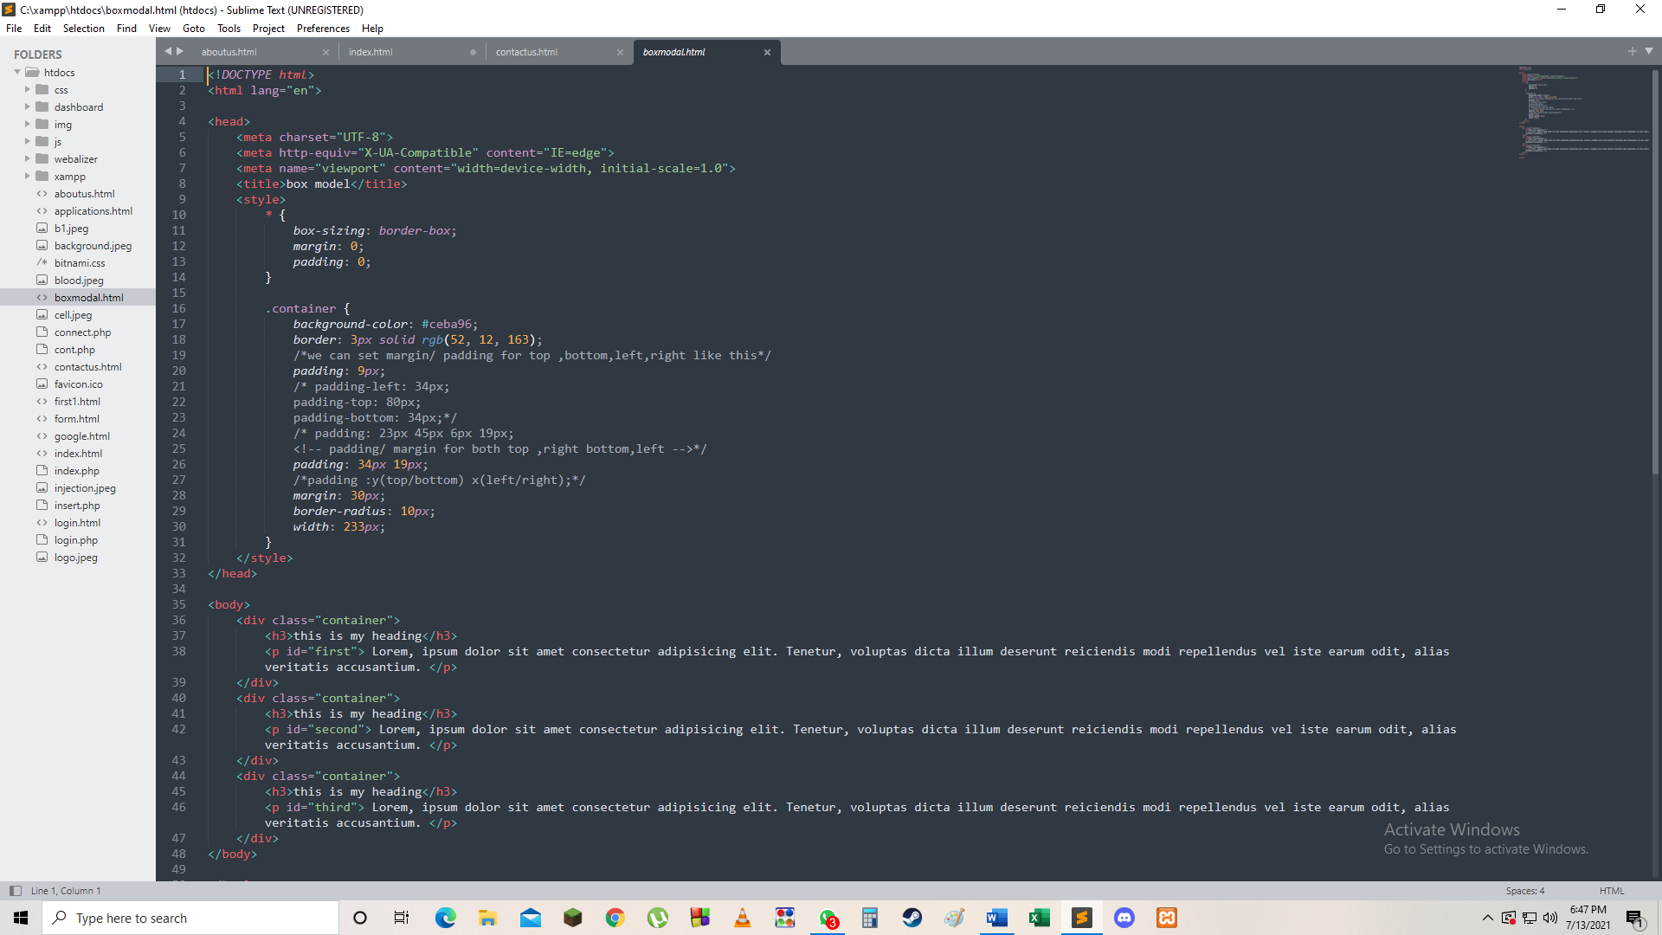

Class D

Future scope

Although it’s a fully working model there are still a lot of improvements to be made such as

* Putting up more information about other blood banks located near the user in India as well as in abroad
* Putting Ai’s bot feature to interact with the user to guide him /her how to operate the website and to clear doubts.